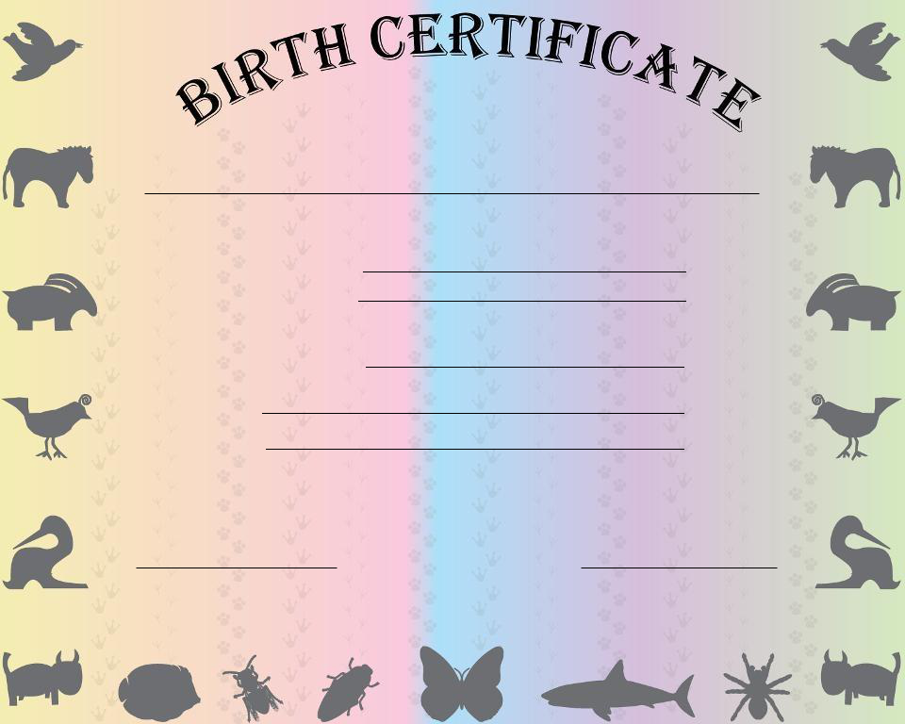

Was born on

at

To human parents

On

at

Name Name

