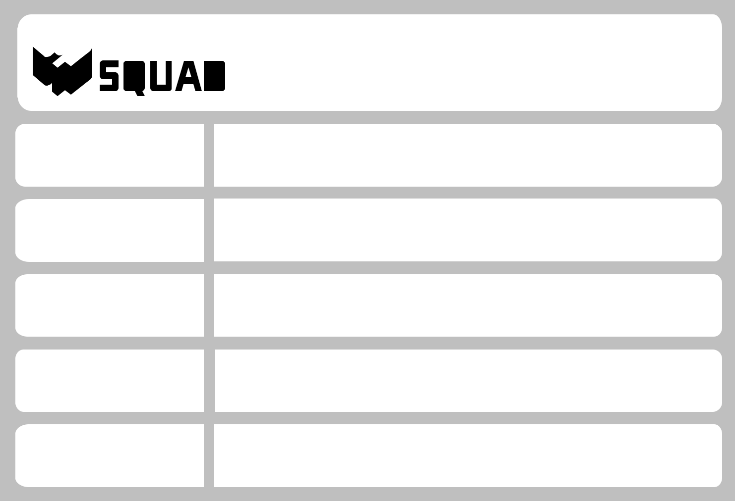
 SHIPPING LABEL

For packing and labeling information visit storagesquad.com/packing/

FULL NAME

CUSTOMER #

SCHOOL

SHIP DATE
 | WRITE “ASAP” FOR IMMEDIATE SHIPMENT (3-7 BUSINESS DAYS)
ITEM # | OF
 | ITEM COUNT IS SEPARATE FROM ITEMS THAT ARE ONLY FOR STORAGE
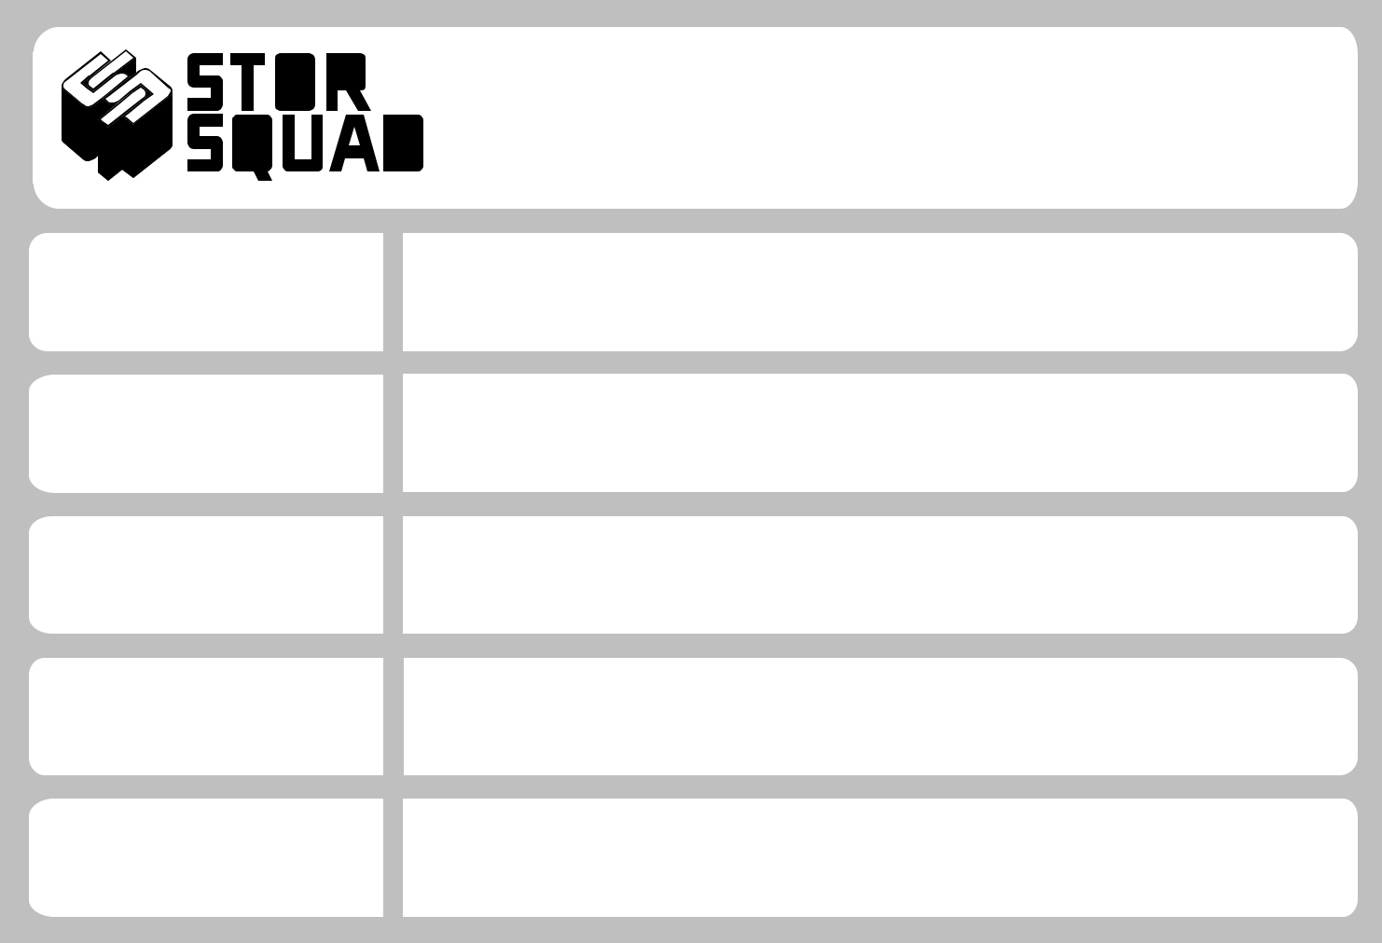

 SHIPPING LABEL

For packing and labeling information visit storagesquad.com/packing/

FULL NAME

CUSTOMER #

SCHOOL

SHIP DATE
 | WRITE “ASAP” FOR IMMEDIATE SHIPMENT (3-7 BUSINESS DAYS)
ITEM # | OF

ITEM COUNT IS SEPARATE FROM ITEMS THAT ARE ONLY FOR STORAGE

