From:

Ship to:
ImmunoLytics

5930 Midway Park Blvd. NE

Albuquerque, NM 87109

FOLD HERE

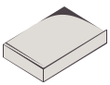 Print Label & Ship Samples
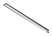

Once sealed and labeled samples the foil bag in the kit box and use to the samples. Use this shipping

are placed inside the foil bag, pack packing filler to prevent any damage label on the box to return to our lab.

