11941-L Bournefield Way, Silver Spring, MD 20904 dodgechrome.com

Shipping Label

- Attach mailing label to a padded envelope and enclose Film Order Form.

Limit of Liability

-

tion, alteration, enlargement, storage, transmission, or other handling, constitutes an AGREEMENT that any loss or damage to it by our company, subsidiary or agents, even though by our negligence or other fault, will only entitle you to replacement

any incidental or consequential damages is excluded. No expressed or implied warranty is provided.

 | Use
From: _______________________________ | Correct
From: _______________________________ | Postage
_____________________________________ | Postage
_____________________________________
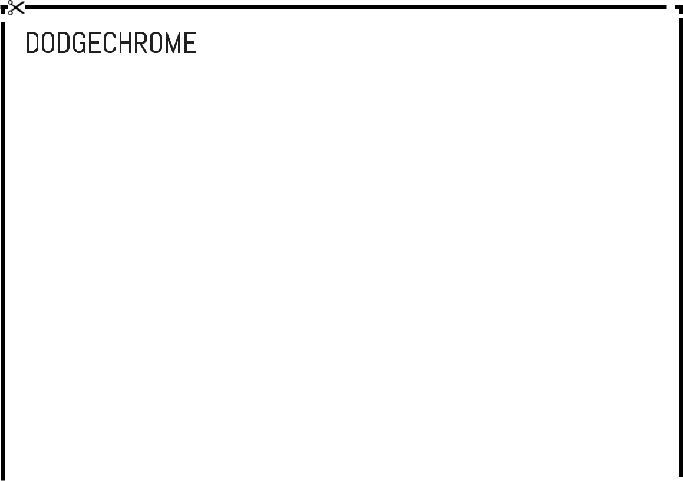

DodgeChrome

11941-L Bournefield Way

Silver Spring, MD 20904

12 19 16

